Description of the data 2017 US News Ranking of the University of California campuses (excluding UC San Francisco). Four columns in the data matrix correspond to:

1. Name of the UC Campus.

2. Rank (among all US universities).

3. Undergraduate enrollment.

4. Percentage of students accepted in Fall 2015.

Result

1. The graph below marks the locations of UC universities. And the state boundary of California is drawn by the white line.

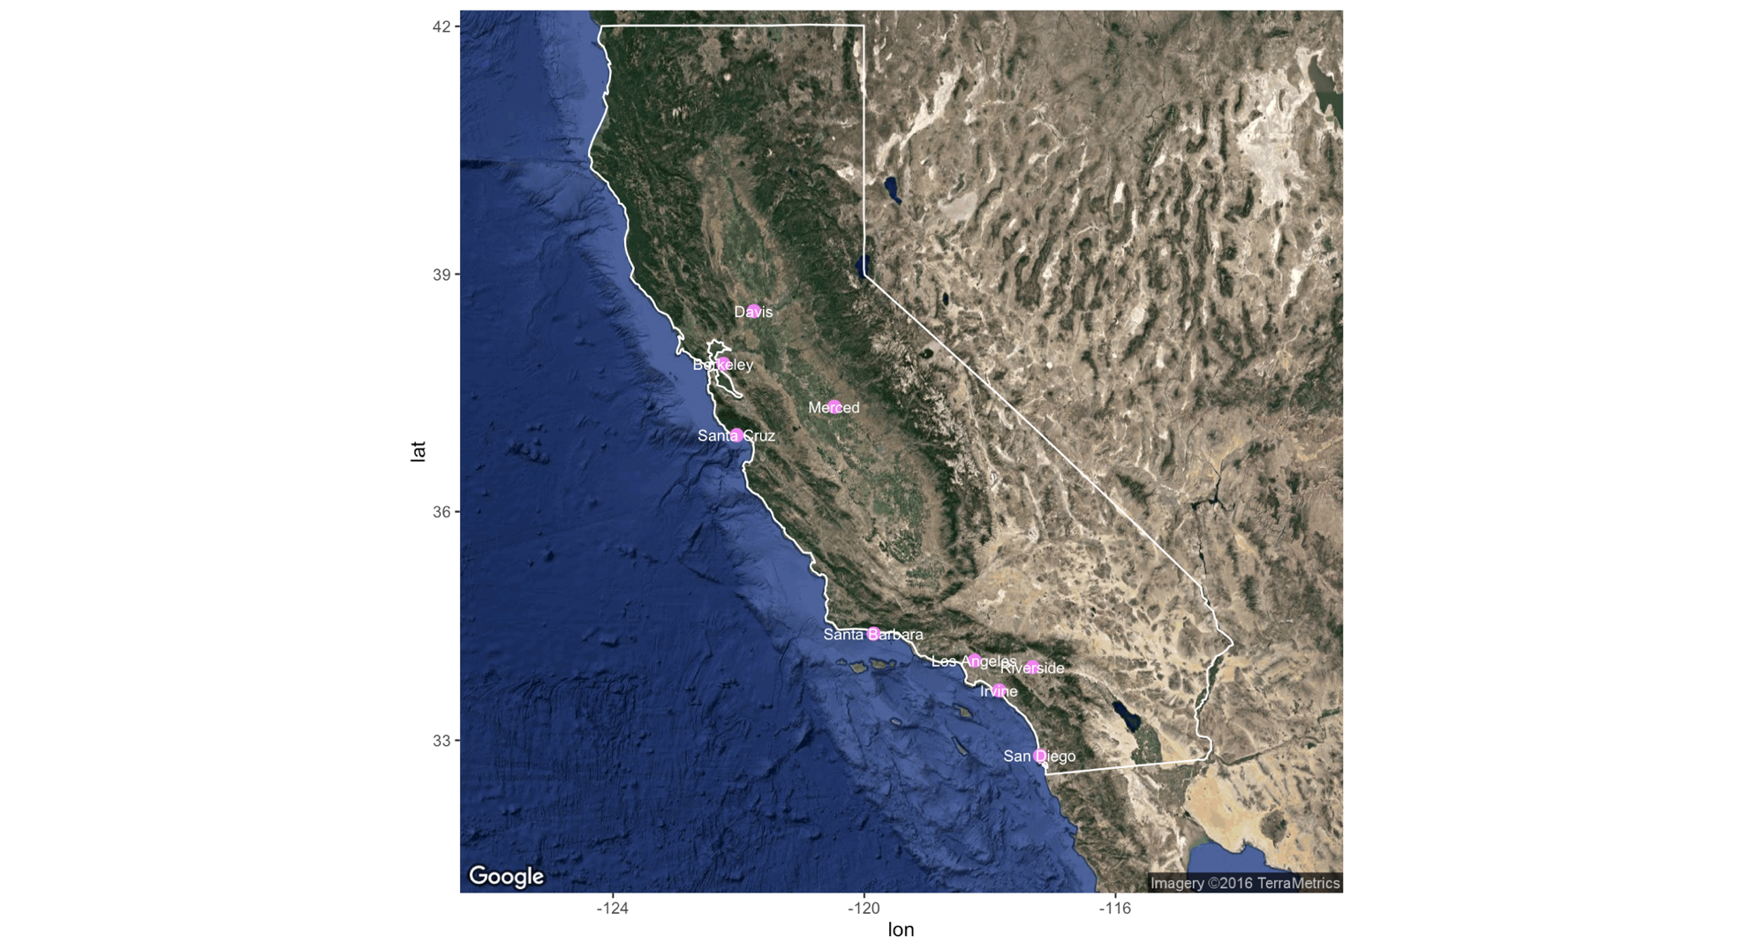

Figure 1 UC location

The ranks of universities are indicated by the sequence of rainbow. So the point of UC Berkeley is red, and the point of UCLA is yellow. On the other side, the color of UCR and UCM is more purple like. The acceptance rate can be separated by the transparency of the point. The more transparent the point is, the smaller acceptance rate is. It leads to the point of UCB and UCLA a little hard to find. And the population of universities are shown by the size of the point: the bigger point implies the certain university has larger undergraduate student population.

* 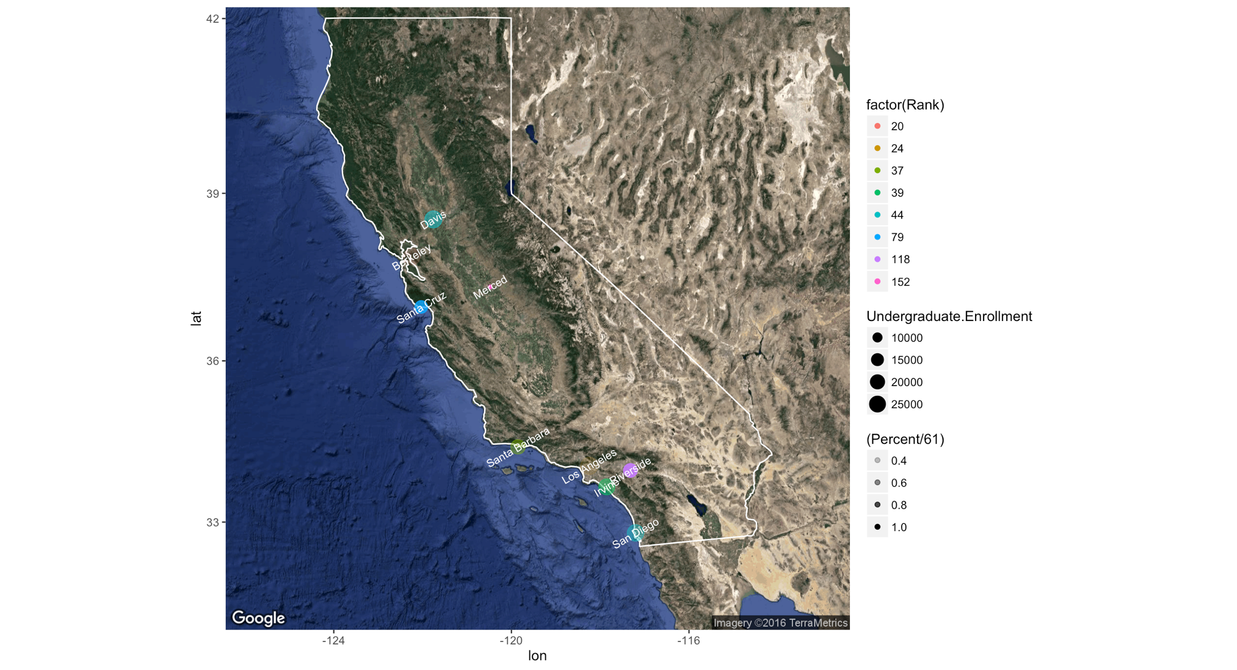

Figure 2 information of UC universities

The yellow lines draw the bicycle road between these campuses.

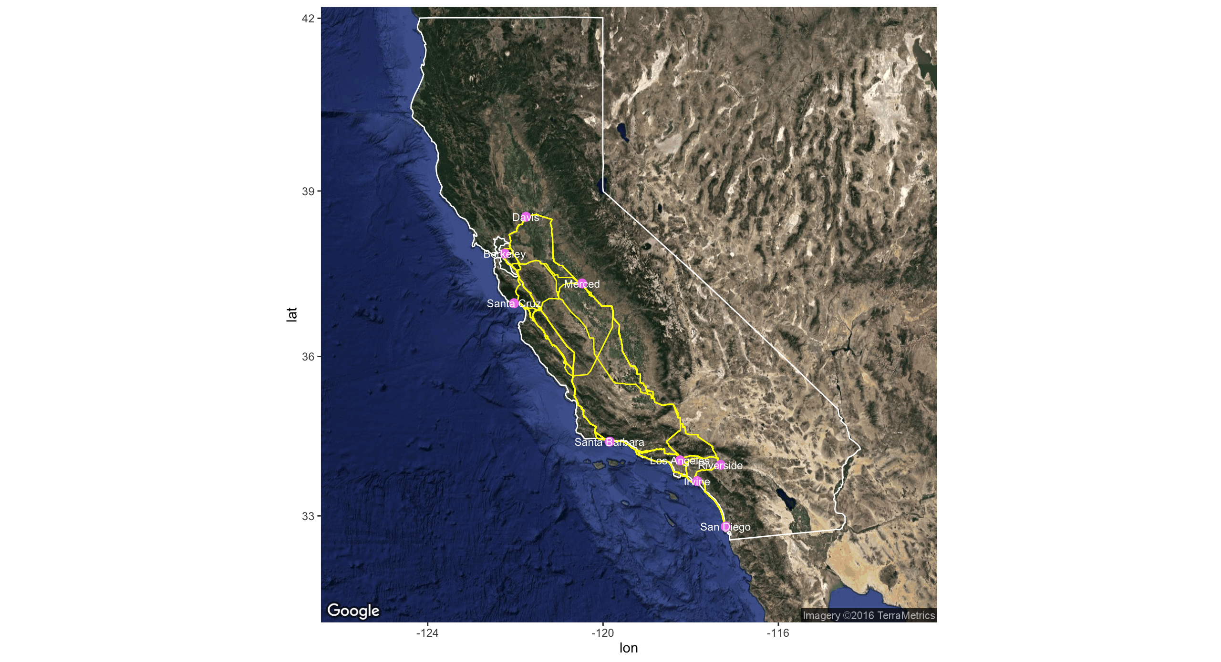

Figure 3 bicycle roads between campuses

The edges between the vertices means that their driving distances are less than 100 miles. It means that UCSB and UCM are relatively far from other campuses.

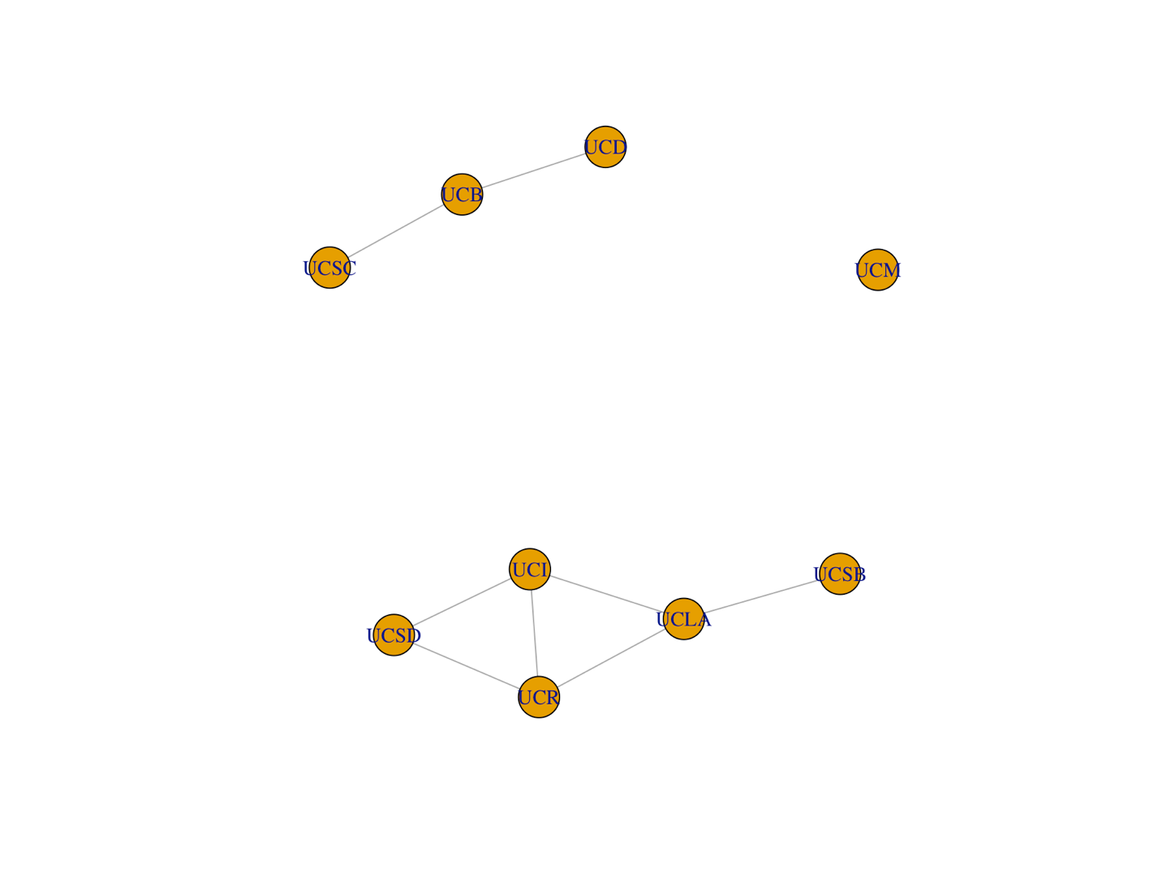

Figure 4 distances between campuses

The red points imply that the universities have a student population which is smaller thatn 20,000. And universities drawn by the green point have more than 20,000 undergraduate students.

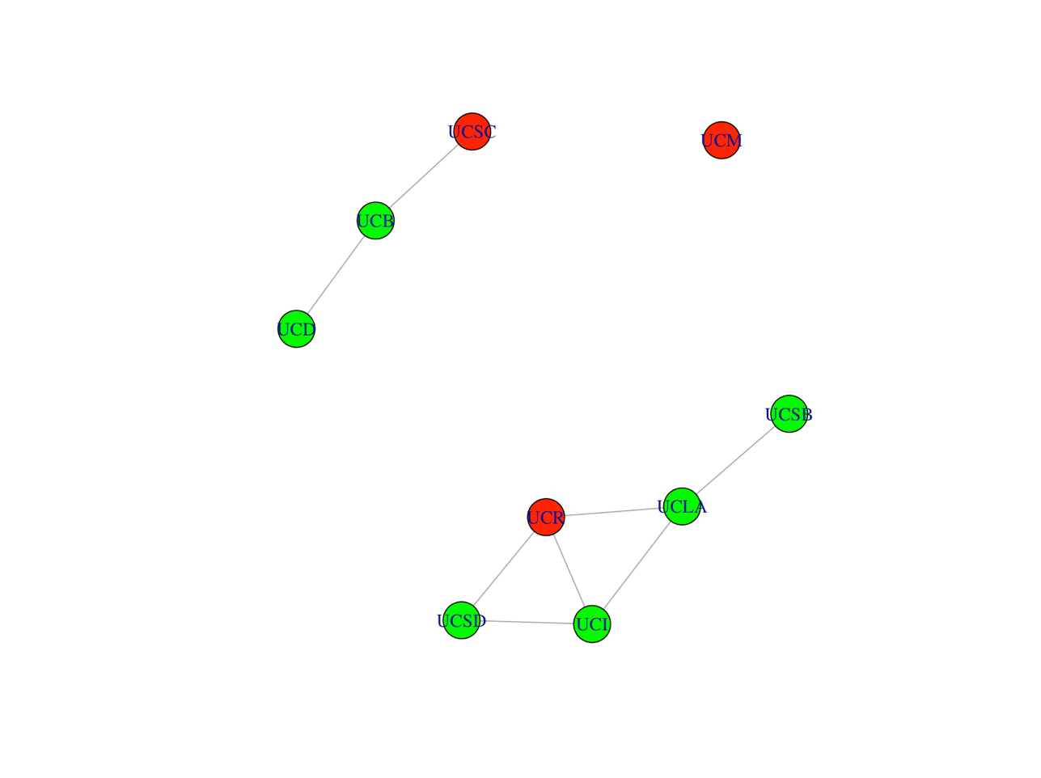

Figure 5 campuses information